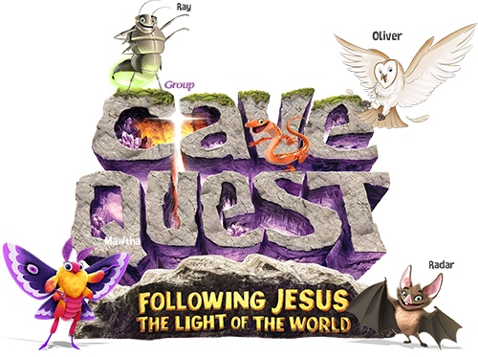
St. Ignatius Vacation Bible School
Registration
July 17-21, 2017
9:00am-11:30
Join us for Cave Quest
Sponsored by the
Julieanne Kriens Memorial Foundation

Please complete and return

Child’s Name _________________________________ Group Assignment ______________________

Birth date __________________________ Age ____________ Grade ______________________________

Name of siblings attending VBS ___________________________________________________________

Parents’ Names ______________________________________________________________________________

Address _______________________________________________________________________________________

City/State/Zip _______________________________________________________________________________

Home Phone ________________________ Work Phone _________________________________________

Cell Phone ____________________________ Email _______________________________________________

If I cannot be reached in an emergency, the following person is authorized to act on my behalf
Emergency Contact __________________________________________________
Relationship ____________________________________________________________
Phone ___________________________ Doctor Name _____________________________________________

Allergy/Health Information :

Permission to use photos taken during VBS on social media/church promotional material: (Please circle) Yes or No

$10.00 per child _______Check _________ Cash (maximum $20 per family)
Snacks will be provided.
Return forms to:
St. Ignatius Church
500 E. Depot Street (at Deep Lake Rd)
Antioch IL 60002
847-395-0652
For questions call: Linda Mizwicki (847) 401-4915

